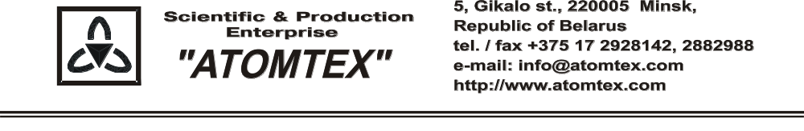
CALIBRATION CERTIFICATE
Date of calibration: 16.08.2019

Type Radiation monitor AT1117M

S/N: 13996

Measurement limits:
PU-2 detector: γ 1,0 μSv/h – 10,0 mSv/h;
BDKG-05: γ 0.03 μSv/h – 300 μSv/h

Measurement error:
PU-2 detector: ± 20 %;
BDKG-05: ± 20 %

Operating conditions:

Air temperature +20°C
Atmospheric pressure 99,1 kPa
Relative humidity 78 %

The instrument is calibrated on the standard dosimetry facility AT-130, N 015, error ±4% (the Certificate of Compliance N 210/1427-2018 on 23.10.2018 issued by FGUP "D.I.Mendeleyev VNIIM", St. Petersburg, Russia); AT-110, N 013, error ±5% (the Certificate of Compliance N 210/1426-2018 on 22.10.2018 issued by FGUP "D.I.Mendeleyev VNIIM", St. Petersburg, Russia).

Calibration data
PU-2 detector (γ)
Conventionally true value (CTV) of dose rate, 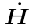*o_{i}(10) | Calibration data,  *_{i}(10)
20.0 µSv/h | 20.1 µSv/h
70 µSv/h | 71 µSv/h
0.70 mSv/h | 0.68 mSv/h
7.0 mSv/h | 6.8 mSv/h

BDKG-05 (γ)
Conventionally true value (CTV) of dose rate, 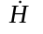*o_{i}(10) | Calibration data,  *_{i}(10)
0.07 µSv/h | 0.069 µSv/h
0.70 µSv/h | 0.71 µSv/h
7.0 μSv/h | 7.0 μSv/h
70.0 μSv/h | 72.0 μSv/h
240 μSv/h | 228 μSv/h

Calibrated by: V. Pisarenko _____________
(signature)
Technical control: N. Kurbatova _____________
(signature)

